## XCODE SETUP GUIDE

This guide is meant for people trying to run the project on an ios device/simulator

You will need a MacBook to run the project on ios

Table of Contents

Installing the IOS development environment 1

Setting up Xcode 2

Importing the Project 2

Setting up Your iPhone 3

Side Notes 4

## Installing the IOS development environment

Complete setup guide: <https://reactnative.dev/docs/environment-setup>

1. Install Homebrew(a package manager)

Paste “/bin/bash -c "$(curl -fsSL <https://raw.githubusercontent.com/Homebrew/install/master/install.sh>)" into a terminal

(You can press command + space to open spotlight and search for terminal)

1. Run “brew install node” in a terminal to install node
2. Run “brew install watchman” in a terminal to install watchman
3. Install Xcode command line tools

This should be installed already when you install Xcode but you can verify it by going to

Xcode(top left of screen) -> Preferences -> Locations -> Command Line Tools

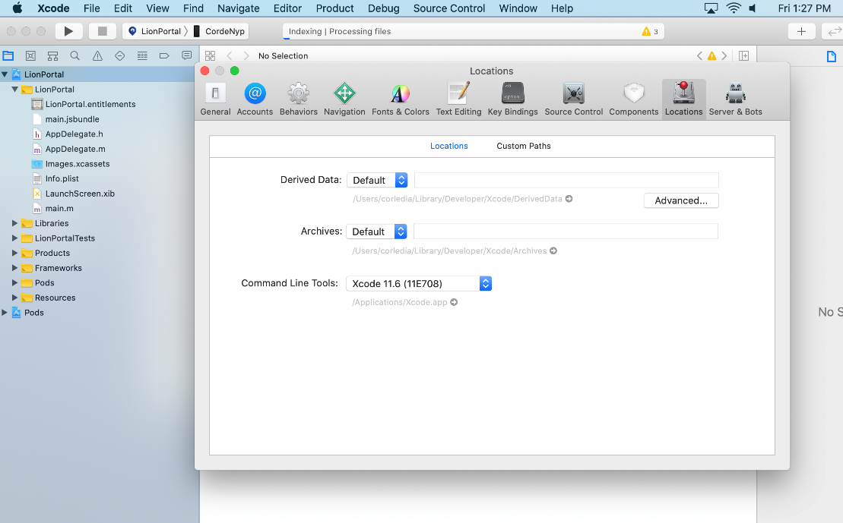

1. Run “sudo gem install cocoapods” in a terminal to install CocoaPods

## Setting up Xcode

1. Open up the app store and install Xcode

If you wish to use Xcode 11, your OS version needs to be **Mojave 10.14.4** or higher, however it is recommended to use **Catalina 10.15**

If you are using Xcode 11, try and update your phone to the latest version also

## Importing the Project

1. Download the project folder onto your MacBook
2. Install the certificate provided by your teacher, should be called cert.p12
3. Open up Xcode and open “<your_project_name>/ios/LionPortal.xcworkspace>

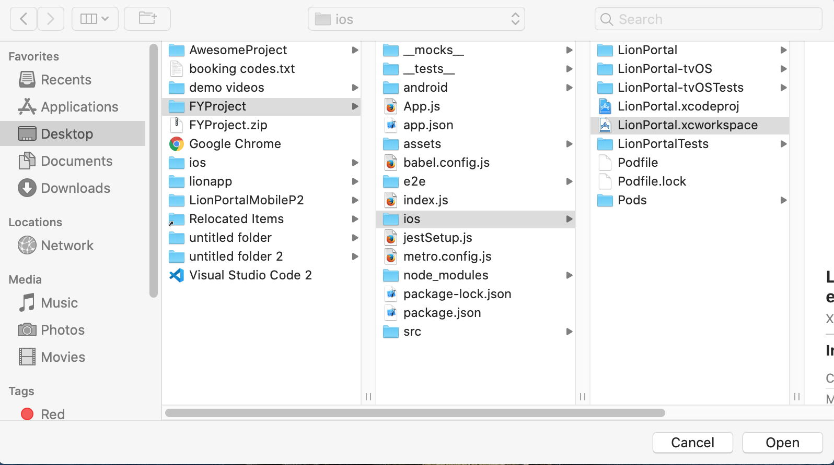

## Setting up Your iPhone

1. When the app is being built, you will receive a notification asking you whether you want to trust the computer or not, click on Trust in order for the app to be installed

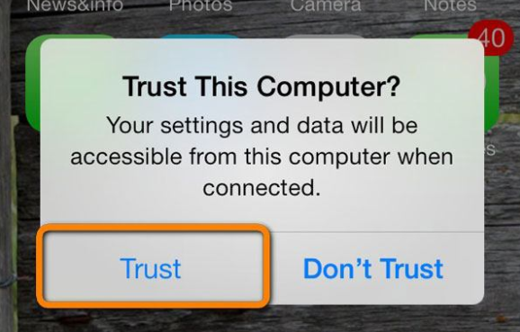

1. After the building the app, go to Settings -> General -> Device Management -> Nanyang Polytechnic -> Trust “Nanyang Polytechnic”, in order to be able to install the app

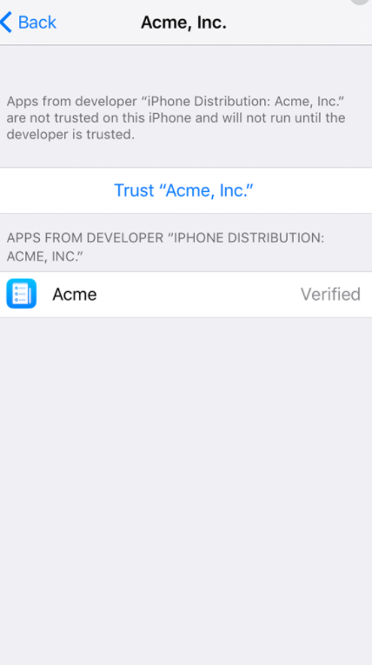

## Side Notes

If you encounter any error that you are unable to fix, sometimes changing to Legacy Build System can help you bypass that error. This can be done by going to File -> Workspace Settings - > Build System

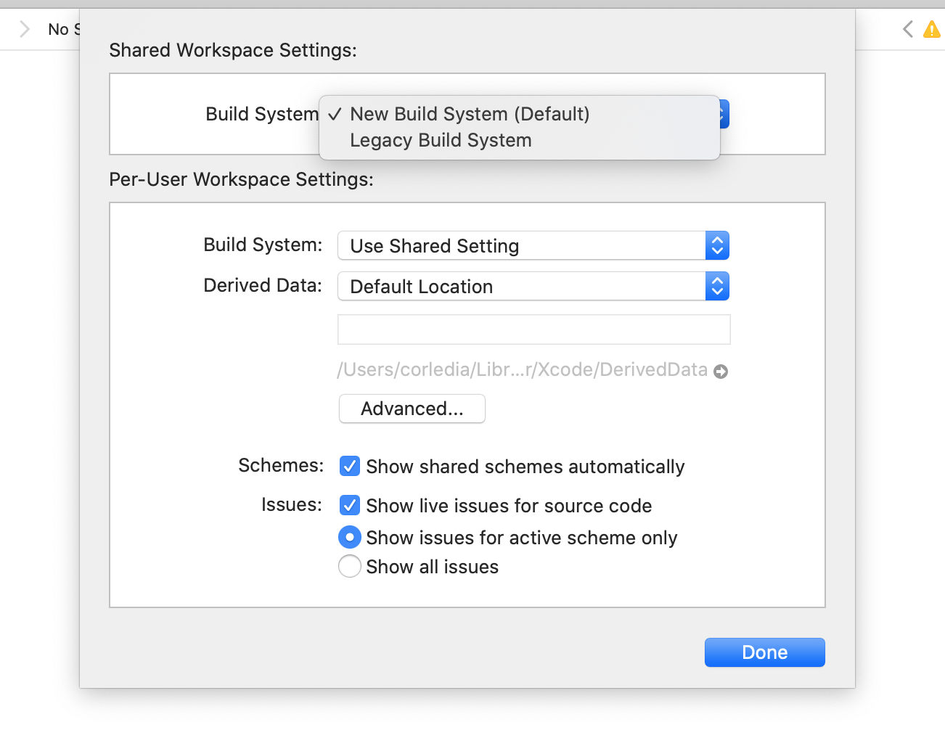

You can also try to delete the DerivedData by going to File -> Workspace settings - > Click on arrow beside the path -> Delete the folder that starts with LionPortal

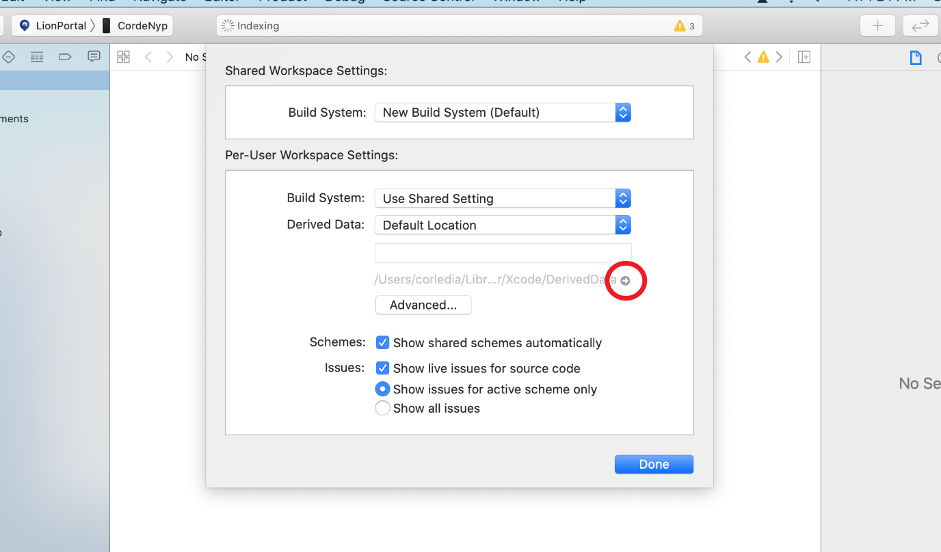

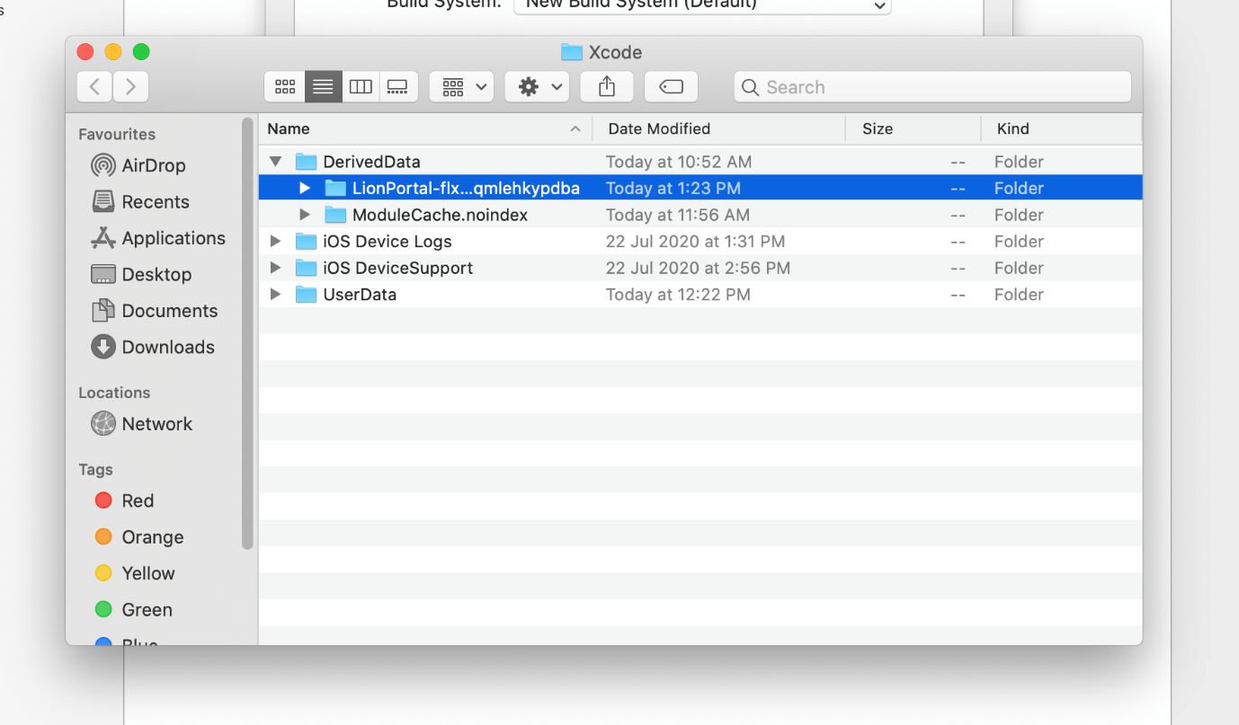

If you get an error saying “No signing certificate “iOS Development” found. Click on your project on the left column -> Click on your project under Targets -> Build Settings -> Signing -> Code Signing Identity. Change the value from iOS Developer to iOS Distribution. Then go to Signing & Capabilities to see if the error has disappeared.

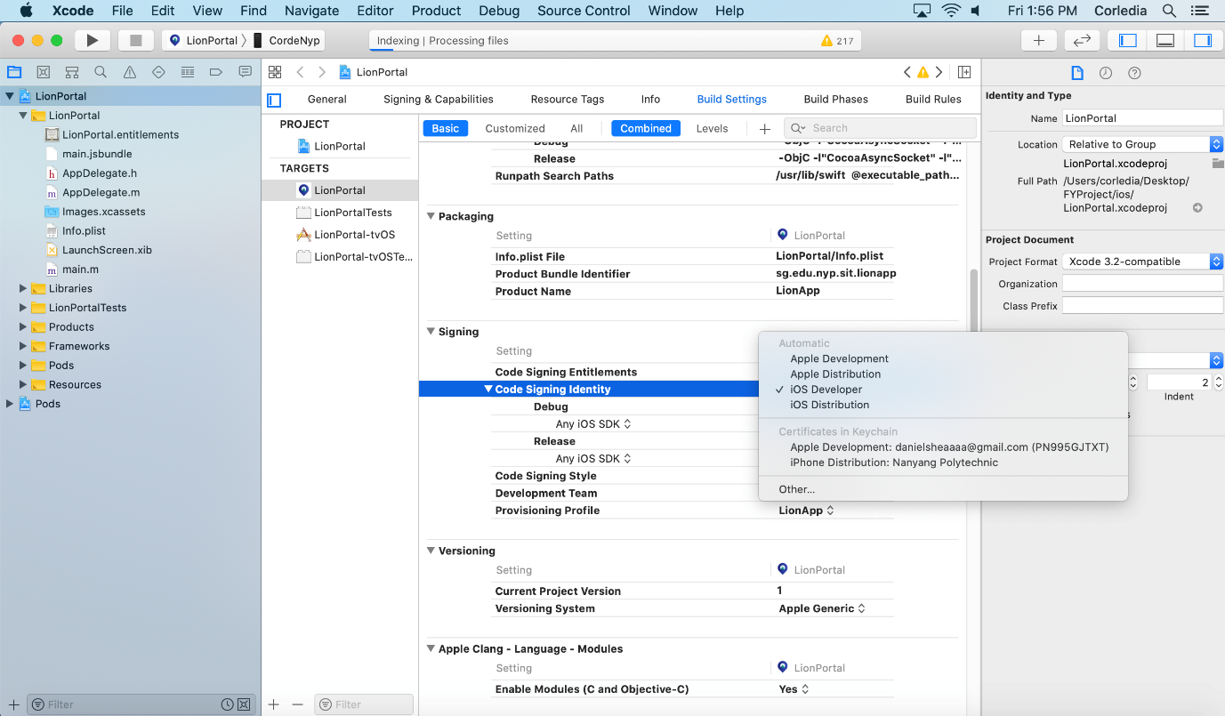

Under Signing & Capabilities, for Signing (Release), uncheck Automatically Manage Signing, and select LionApp for the Provisioning Profile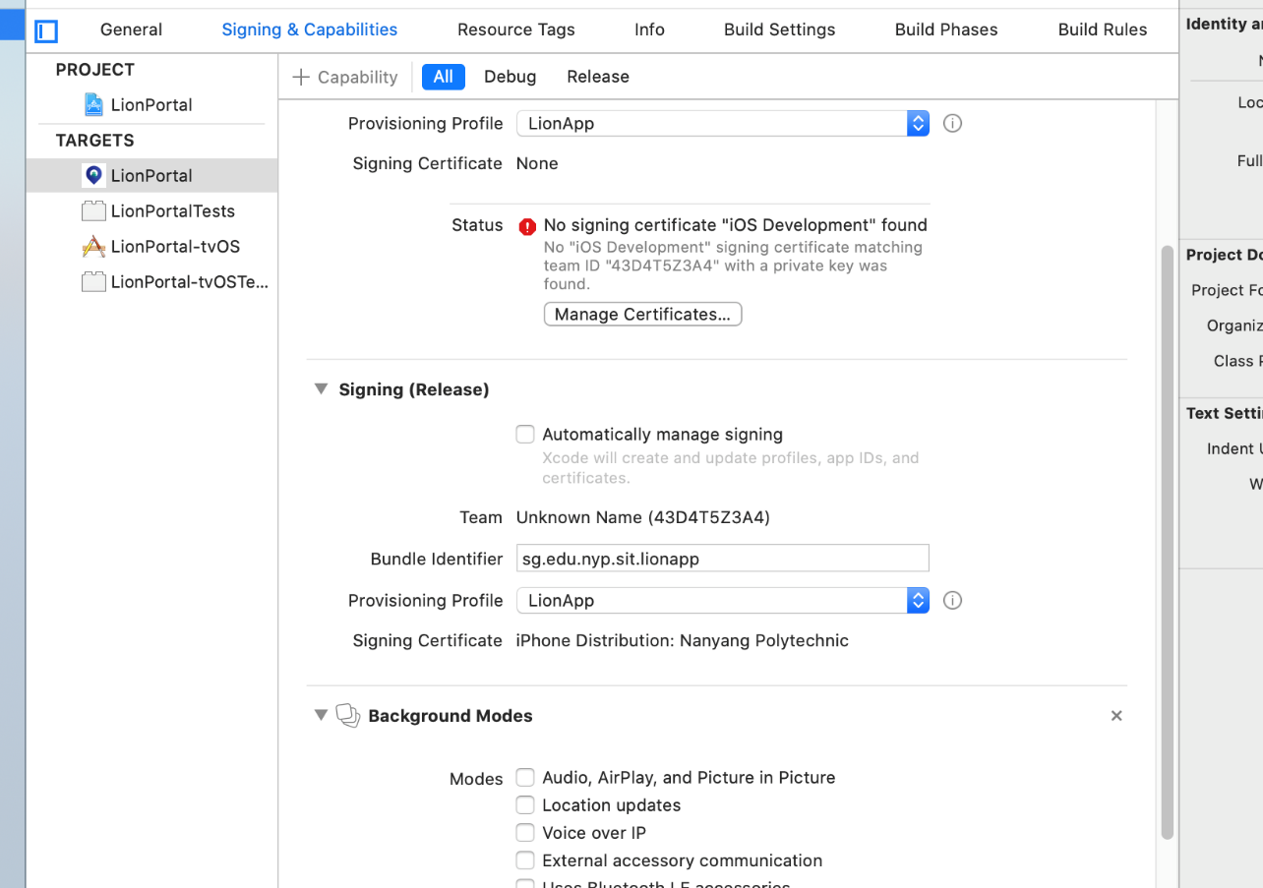

Good luck!

THE END